**Routing Document to Other Department or Branch**

1. Login to e-Dokyumento and select ‘Routing’ or ‘Incoming’ from the side menu.

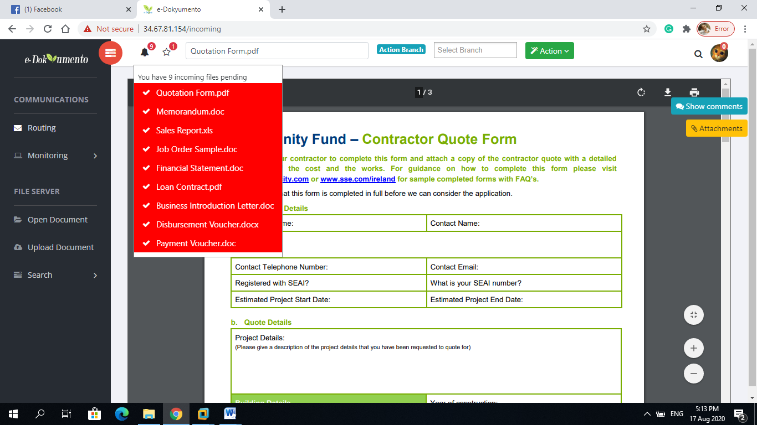

1. Click on the bell notification icon and select the document file.
2. When adding ‘Reference’ attachment to the main document, click on the ‘attachment’ button at the right side of the screen the click ‘add’ button.

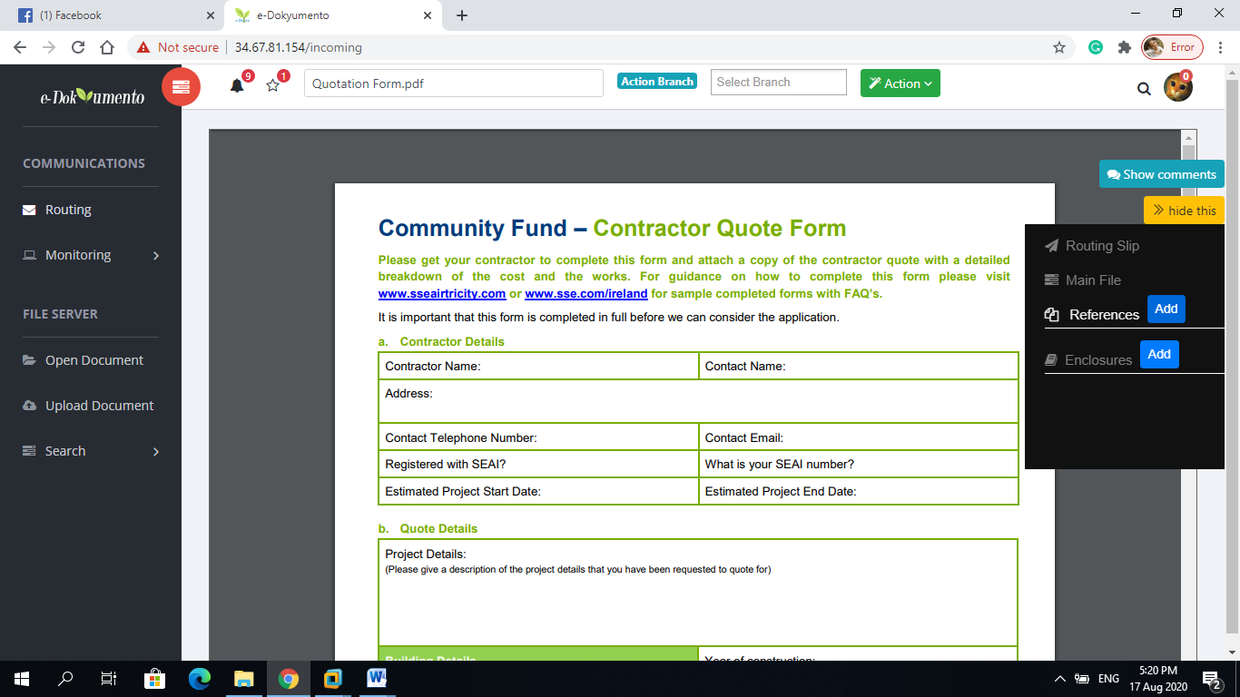

1. Browse for the file by double clicking on the folders to expand and then select the file.

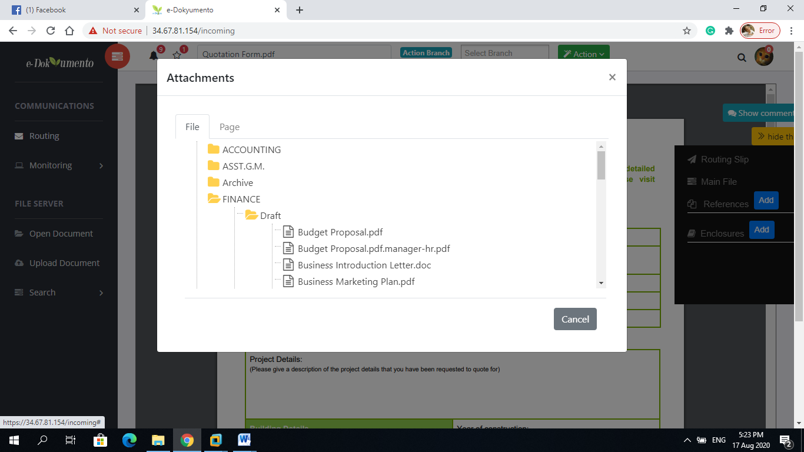

1. Same can be done with the enclosure.
2. When adding comment to the document prior routing, click on the ‘show comments’ button.
3. Type-in your comment and click ‘add’.

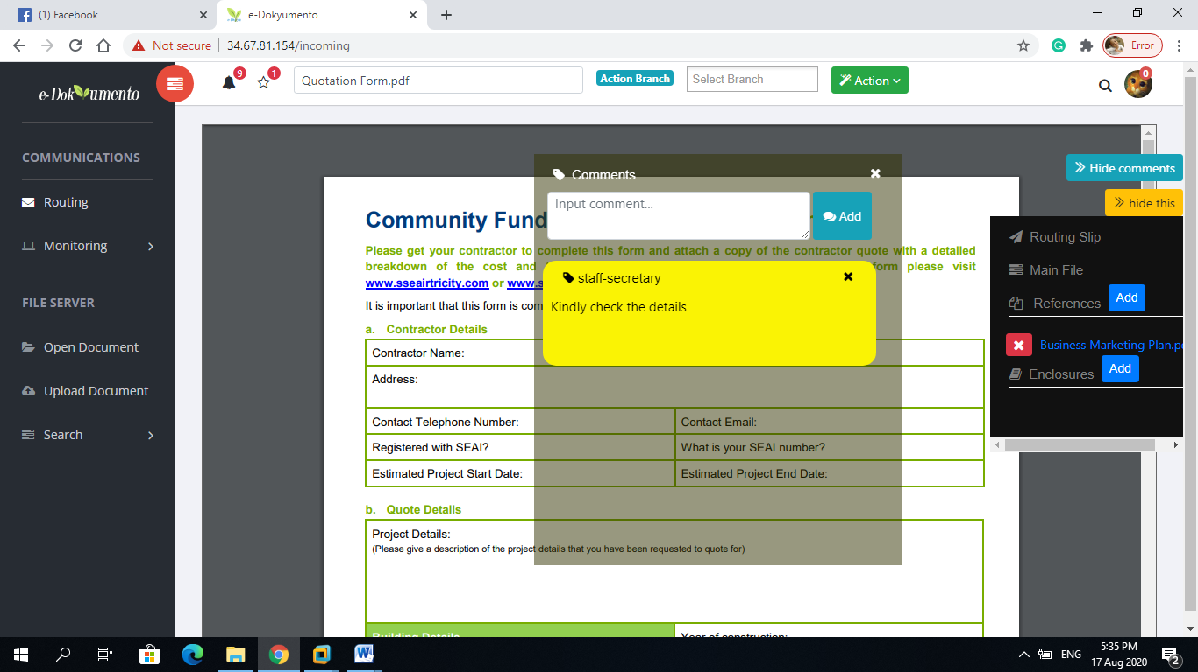

1. To route the document using the ‘SECRETARY-RECEIVING’ privilege, select the target branch or department then click ‘action’ button then ‘route to branch’.

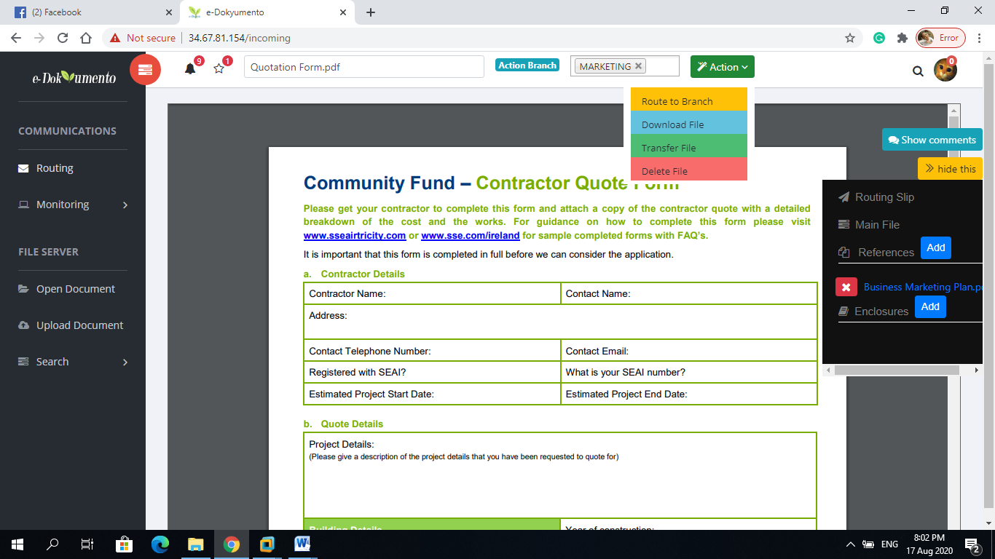

Or when using “STAFF” and “MANAGER” privileges, select the ‘correspondence’ type and then click ‘action’, ‘route to branch’, then select the target branch from the choices given.

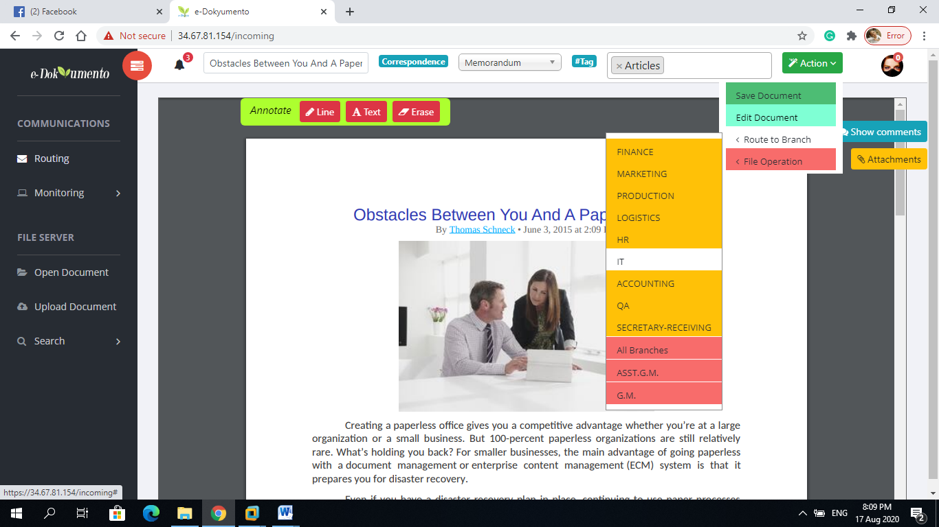

**Select or type-in ‘tag’ for hashtag searching. Type any word then press enter**

1. The routing dialog box will appear. You can optionally select the required action and type-in remarks into the routing slip. When done, click “sign w/ password” to sign the routing slip and reflect all entries.

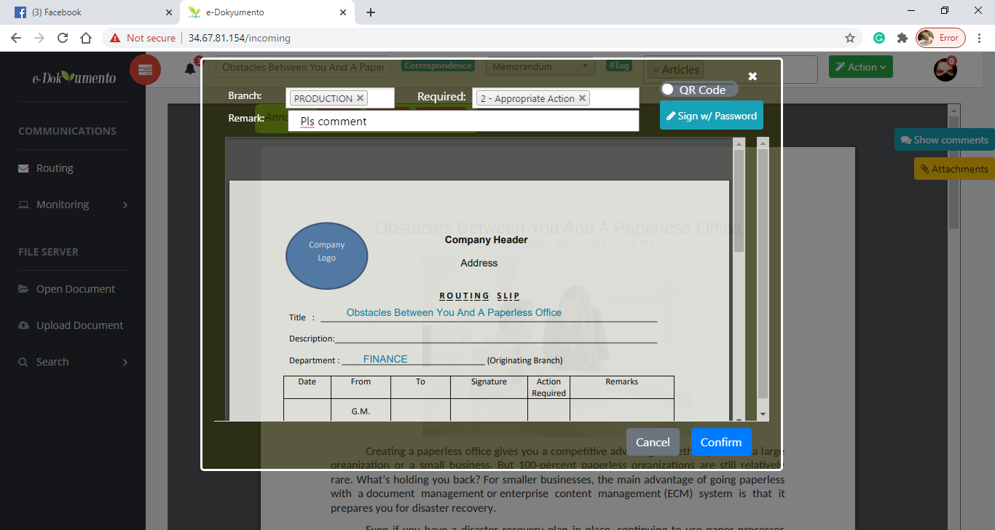

1. The password text box will drop from the header. Type-in your password to verify the signature the click ‘validate’.

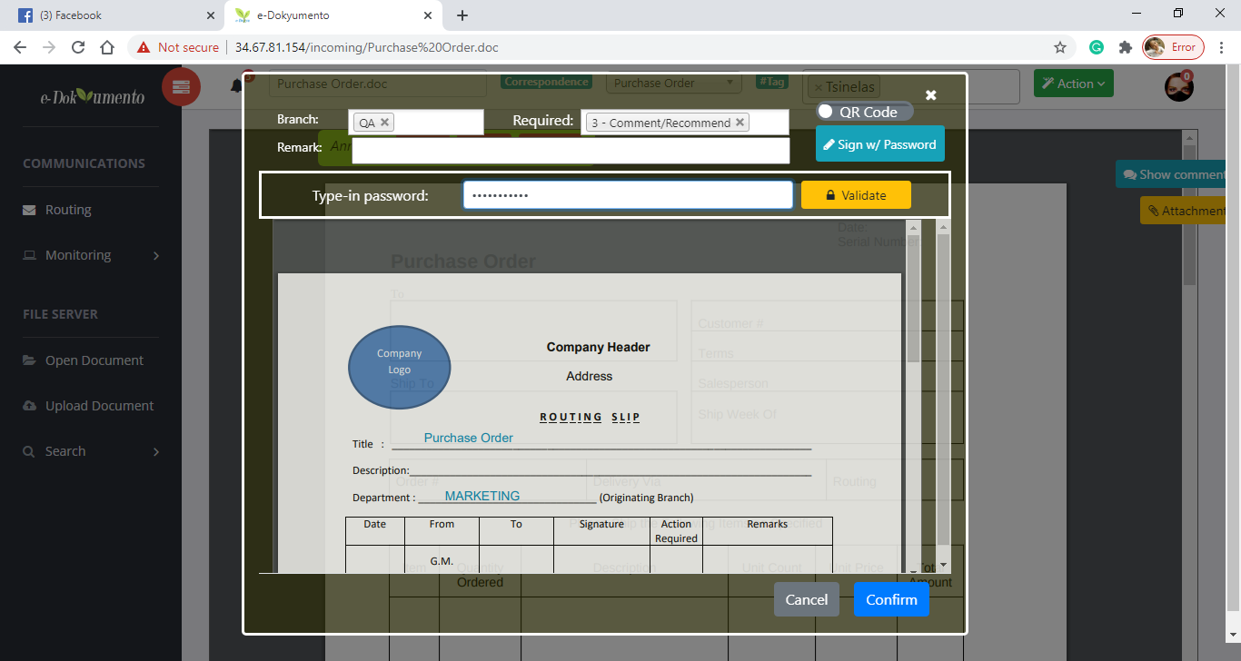

1. The routing slip will then be updated. Click ‘confirm’ button at the bottom of the dialog box to finally route the document together with the attachments, comments, and routing slip.

